**LASER POWER TRANSMISSION VIA LASER**

**ABSTRACT**

* Wireless Power Transmission (WPT) using laser technology has emerged as a promising solution for transferring electrical energy without the need for physical cables.
* This technology uses laser beams to transmit energy over the air, enabling the efficient and safe transfer of energy over long distances.
* In contrast to other forms of WPT, laser-based WPT has several advantages such as high power density, high transmission efficiency, and the ability to transfer energy over long distances.
* Moreover, the use of laser technology eliminates the need for electrical conductors, reducing the risk of electrical shock and increasing the flexibility and mobility of power transfer.
* However, implementing WPT using laser technology is not without its challenges.
* Precise alignment between the transmitting and receiving units is crucial for effective energy transfer, and the laser beam must be properly focused to ensure maximum efficiency.
* Safety concerns also need to be addressed, as the high power density of the laser beam presents potential hazards to human eyes and skin.
* Despite these challenges, the potential applications of laser-based WPT are numerous, including the wireless charging of portable electronic devices, the powering of unmanned aerial vehicles (UAVs), and the transmission of energy to remote locations without access to electrical grids.

**EXISTING SYSTEM**

* Transmission lines carry electric energy from one point to another in an electric power system.
* They can carry alternating current or direct current or a system can be a combination of both.
* Also, electric current can be carried by either overhead or underground lines.

**DISADVANTAGES**

* An AC transmission line has line capacitance. Therefore, there is a continuous power loss in the AC transmission line
* 2-4% of energy is lost in the transmission lines
* 4-6% of energy is lost during the distribution
* So, the average loss of power between the power plant and consumers ranges between 8-15%.
* In technical loss we have radiation loss, conductor loss, dielectric heating loss, coupling loss and corona loss.

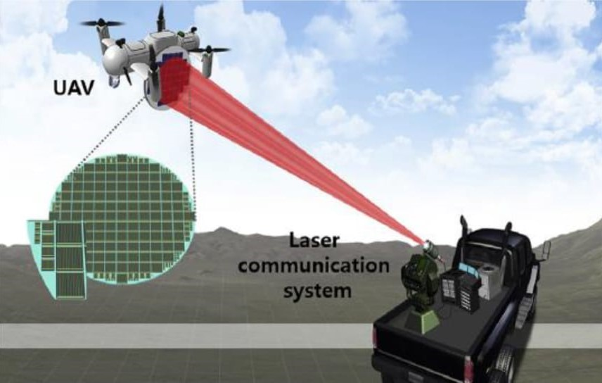

**PROPOSED METHOD**

* Laser power transmission (LPT) is considered a potentially efficient way for power delivery.
* Especially in long distance wireless application.
* LPT has many advantages such as lower device size and high power density.
* The utilisation of LPT can resolve the llimitaion problem in a wired connection.
* The influence of electromagnetic interference in application and high temperature fields can be reduced.

**ADVANTAGES**

* Laser power transmission is a potentially efficient way for power delivery.
* The technology including transmission of power both to and ground,spacecraft,aerial vehicles, satellites and lunar rover
* No conductor required for power transmission
* Reduce the losses in transmission lines

**HARDWARE REQUIREMENT**

* SMPS
* CONCENTRATED SOLAR
* LASERPO
* 10K TENTIOMETER
* TRANSISTOR – BD139,TIP3055,LM317
* VOLTAGE REGULATOR – 7805
* DOIDE - 1N 4007

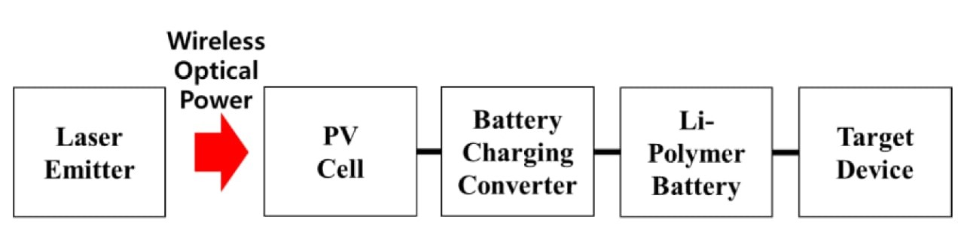

**RPS**

Almost all electronic devices used in electronic circuits need a dc source of power to operate. The source of dc power is used to establish the dc operating points for the passive and active electronic devices incorporated in the system. The dc power supply is typically connected to each and every stage in an electronic system.

**BLOCK DIAGRAM**

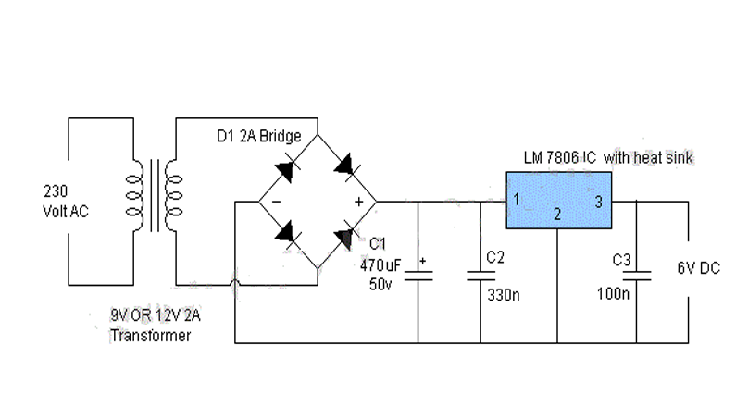

**LASER**(Light amplification by stimulated emission of radiation)

The transmitter of the system converts power from a common source (battery, generator, or grid) into a monochromatic beam of light via a laser. This laser beam is then shaped with a set of optics, and directed via a beam director to the remote PV receiver.

Lasers are divided into four classes ,class 3 is divided based on the accessible emission limit. And the overall classes depend upon the beam and the wavelength of the emitted energy. The classification is based on the laser power, wavelength, and exposure duration. Classification are based on the potential for the beam to cause injury and damage from direct exposure or diffuse reflective surfaces.

MSFC/UAH engineers investigated Cu:In:Ga:Se2, Si, Ga:In:P2, Ga/As/Ge, and GaInP2/GaAs/Ge cell materials. Many other device materials were examined, some of them not yet commercially available.

The obtainable lasers studied were the Nd:YAG laser, the Yb:YAG laser and 808nm, and 940nm diode array banks.

The 940 nm diode array banks were chosen due to their high efficiency (50% E-O) and their high power and availability. The Si cells were then chosen to be a good cost effective match to the array wavelength.

**CPV** (Concentrator photovoltaics)

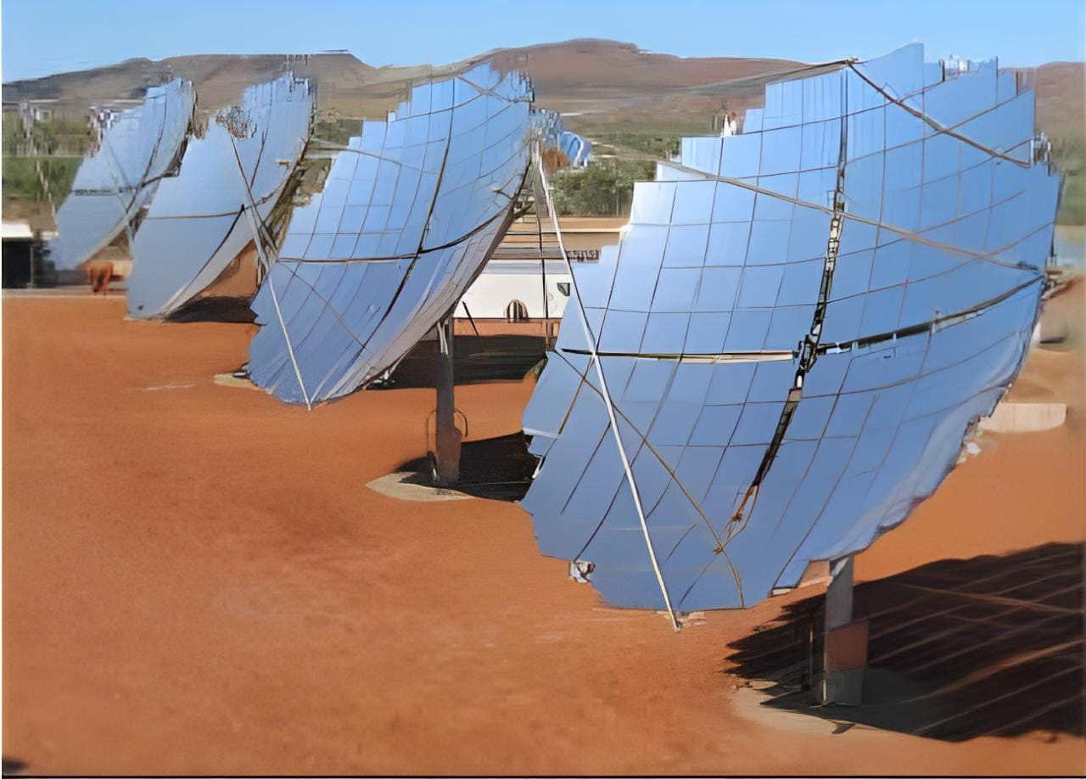

Concentrator photovoltaics (CPV) (also known as concentration photovoltaics) is a  technology that generates electricity from sunlight.

Multijunction solar cells have delivered high efficiencies under the terrestrial spectrum, recently reaching 39% at AM1.5D.

 it uses  lenses or  curved mirros to focus sunlight onto small, highly efficient, multi junction  (MJ) solar cells In addition, CPV systems often use solar trackers and sometimes a cooling system to further increase their efficiency

A conventional single-junction solar cell has a characteristic bandgap Eg. When a photon of energy hm is incident upon the junction, if hm is greater than Eg.

In order to apply super-high-efficiency cells widely, it is necessary to improve their conversion efficiency and reduce their cost.

theoretical and realistically expected conversion efficiencies of single-junction and MJ solar cells in comparison with experimentally realized efficiencies. Therefore, concentrator 3- and 4-junction solar cells have great potential for realizing super-high efficiency of over 40%.

As a 3-junction combination, GaInP/InGaAs/Ge cell on a Ge substrate will be widely used because this system has been already developed.

**SOFTWARE REQUIREMENT**

* Proteus
* Solidworks (software)

**APPLICATION**

* ­­LONG RANGE POWER TRANSFER
* MILITARY DRONE CHARGING